**Of Mice and Men**

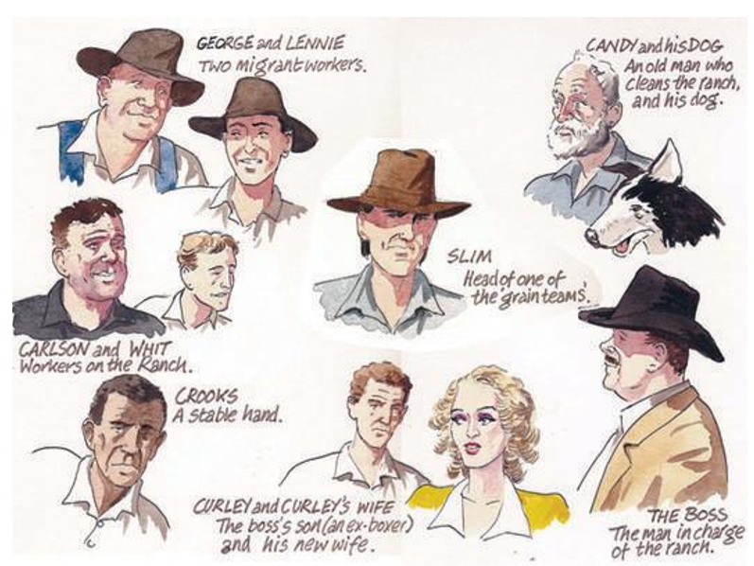

Prior to starting lessons in September, it is crucial that you have secured your knowledge and understanding of ‘Of Mice and Men’. When we cover this in Y11, we are doing so on the basis that you know the novel, including the characters, plot, key themes and ideas.

This booklet contains a lot of key information from the novella. You should read, memorise, and test yourself on the key facts. Remember, this is a closed book exam, so you have to be able to remember everything about the novel.

It is recommended that you print this booklet to complete it on paper.

KNOWLEDGE ORGANISER

A knowledge organiser is a fantastic way for you to collate your information in a succinct way. You can research examples of these online. Please hand in your knowledge organiser for Of Mice and Men to your teacher in September.

