Literature Year 12 Summer Project

In preparation of Year 12, the most beneficial thing you can do is to read the set texts that you will be covering. Over the summer, read through the texts below in detail and keep a diary of your personal thoughts and opinions that arise whilst you read. This is your reading journal and will become an invaluable companion to you in your Literature studies.

Take this summer as your opportunity to really read for pleasure and enjoyment.

- Othello
You should also log in to Digital Theatre Plus to view the theatre performances of Othello. There are modern adaptations. Viewing a range of interpretations of the play is a crucial part of your course. https://www.digitaltheatreplus.com/user
Password: stu123

Copies of the below books can be found on Amazon or Kinokuniya.
Please purchase your own copies that you can adorn with your own notes and reflections.

- Death of a Salesman
The Dustin Hoffman film version of DOAS is also recommended. You are advised to watch this film and think about how it compares with the play.
- Kite Runner
Check for resources and interviews on Digital Theatre Plus.

- Poems of the Decade
Some fantastic modern poetry here for you to enjoy.

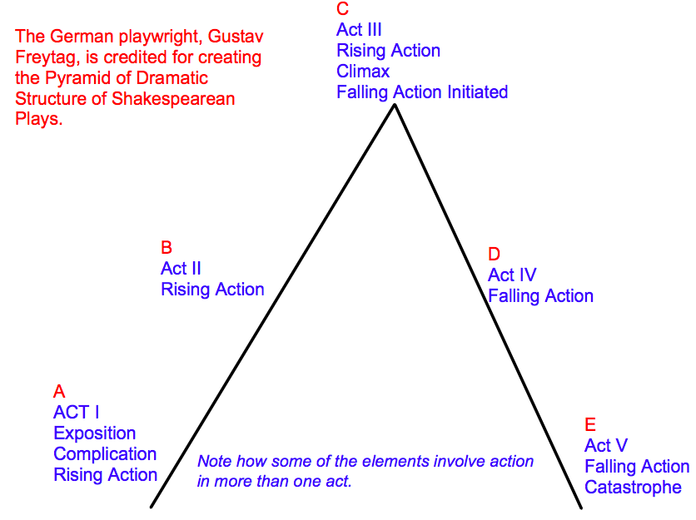
Othello: the structure of the play and the events

Look at the above structural image of a Shakespearean Tragedy. How does Othello reflect this structure? Complete the table below. Look at my own example to help you.
Act | Aristotle Structure feature | Define | What happens?
1 | Exposition | Introduce main characters and the potential for areas for future dramatic conflict | Introduced to Othello and his noble status, learn Iago’s motivation and desires. Othello & Desdemona’s love is exposed. Iago encourages Roderigo to support him for his own gain.
2 | Rising Action
3 | Climax/Complication
4 | Falling action
5 | Resolution/dénouement

1. What do you notice about the structure of the play? How does it help the plot and story?
2. How does the audience respond and react during each different act and why is this? (consider both the Elizabethan audience and contemporary audience)
3. How does Shakespeare use the series of events to reflect Iago’s cunning nature?
Othello as Revenge Tragedy
It is clear that I____ seeks r_________ for a rumour that he does not know is t_______. Throughout the play he is d_________ that O_______ will be p_______ for his s_________ i__________. Thus, we must explore Othello, not only as a tragedy but also as a revenge tragedy.
Research and complete these tasks
Define the form of the Revenge Tragedy:

List at least 3 conventions that you would find in a Revenge Tragedy play:

How does this link to Othello? Make notes below on the connections between the play and the conventions found in a revenge tragedy.

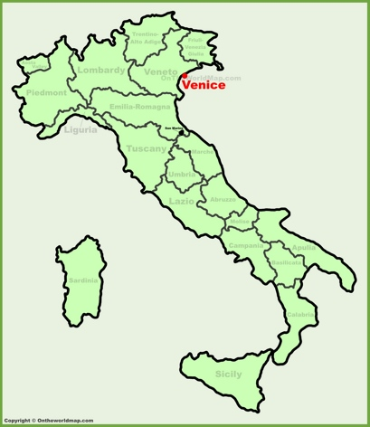
Setting in Othello
Shakespeare purposely chose to set the opening of Othello in Venice.
Research as much as you can about Venice towards the end of the 16th Century.
What was Venice associated with?

Why might Shakespeare have chosen to open with a character who is originally from Venice, Iago, and a character who is doing incredibly well for himself and yet an outsider, Othello?

Shakespeare then transports his audience to Cyprus.
Again, research the significance of Shakespeare choosing Cyprus as his secondary location and the idea that he has purposely chosen to have the plot supported by a background of war with the Turks.

Consider the atmosphere this may create.

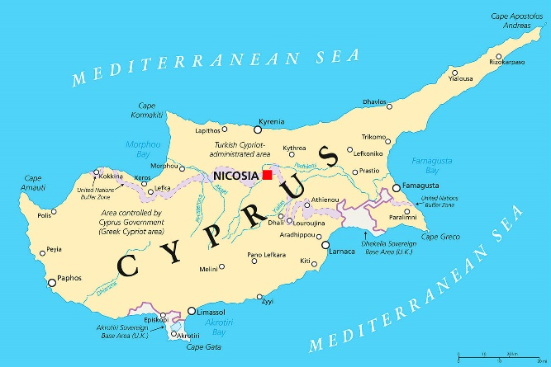

Why did Shakespeare decide to move all of his characters to a garrison town, a ‘half way house’ in Cyprus?

Monologues & Soliloquies
A monologue is a speech made by a character to other characters, sometimes to a crowd.
Look at Iago’s monologue to Mountano in Act 2, 3. Line 207.
Why does Shakespeare give Iago both monologues and soliloquies?
Consider the way in which this impacts the way the audience perceive him. Are there any other characters who are also given both? And why do you think this is?

Key fact: Iago is the character with the most lines in the play, totalling at 1,097. Why do you think this is the case?

There is something very interesting and enigmatic about a soliloquy: there are so many choices, for though the form is the same, i.e. the laying out of the premise, the development of the argument leading to some sort of conclusion, it is nevertheless the thoughts of a single character. And for the actor I think it begs two questions:
1. Has the character made up his/her mind about the resultant resolution before they start to speak, but in order to clarify their position and possibly justify themselves, they need to speak their thoughts through aloud?
2. Or does the character start with the initial thought or idea, not knowing what the end will be, so that it is the words themselves that feed the progression of the thought, and thus lead to a resolution?
Berry, Text in Action, 2001 p.174

Look at both Iago’s soliloquy (Act 2, sc 1, li 277) and Othello’s soliloquy (Act 5, Sc 1, li 1)
Use Berry’s comment above and decide whether or not the soliloquy demonstrates question 1 or 2.
Explain why you think this.
Is there a similarity or difference between these two soliloquies and if so, why do you think this is the case?

To consolidate knowledge from your reading journal…

CREATE KNOWLEDGE ORGANISERS

Self-Quizzing Strategies
We recommend:
Read, cover, write, check: You can learn key information in Knowledge Organisers by reading a small section, covering it up, saying the definitions to yourself, writing out those key terms and definitions in your book, then checking to see if you got them right. You should correct any errors in purple pen, then repeat the process.

The Leitner System: create question and answer flashcards with a question on one side, and an answer on the other (or key terminology on one side, and definitions on the other). Then test yourself several times a week, and revise each card depending on whether you got it right last time or not.

Benefits of Knowledge Organisers
1. Learn as you write
As you layout the information into your chosen format, you can try to write the information down without referring to your reading journal, thus creating your “first layer” of revision. As you build, so too do you start to become more familiar with the content.
2. Gives you the “big picture” overview, which is good for detail retention
It’s true that a knowledge organiser has no room for all the detail, but there are benefits to first ascertaining and mastering the ‘big picture’ information before you move on. Creating the big picture helps you to think more strategically and better connect the details to a root topic. This in turn helps you build connections between information that makes you better able to both understand and recall detail for use in the exam.
3. Works together with other study methods
If you pair this method with other study strategies like retrieval practice, then you can further increase effectiveness and link your revision activities together in a meaningful way. For example, you might use retrieval practice to create your first rough version of the knowledge organiser, or you may use the finished organiser as a point of reference to ask/answer retrieval practice questions.
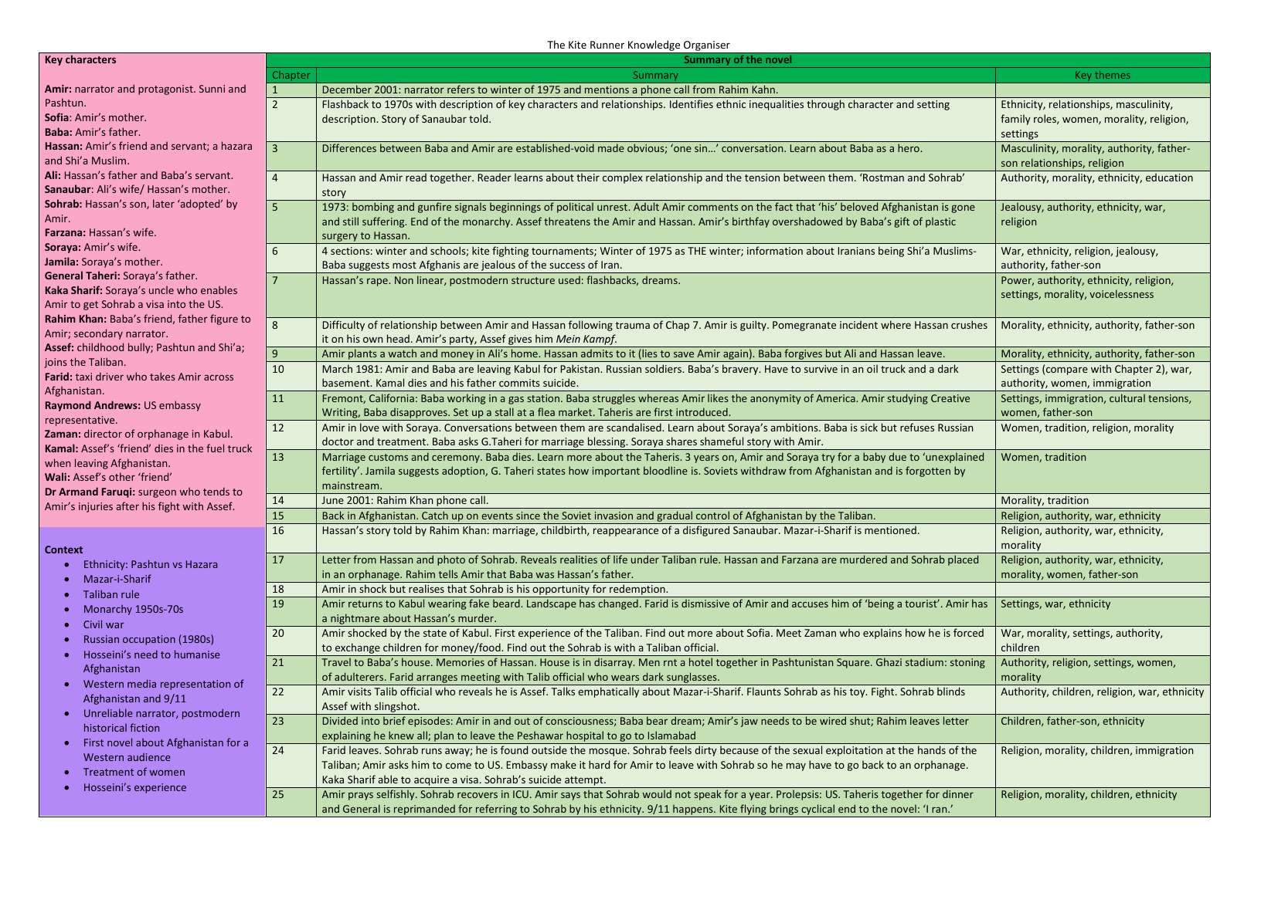
Here is an example of a knowledge organiser. You may wish to adapt the style according to your reading notes and the ideas in your journal.

