

**Summer Prep Booklet**

Dear Parent,

This booklet contains an array of activities for your son/daughter to complete over the summer break. It is crucial that students continue to practise their English skills during the holidays and we encourage students to continue using **Accelerated Reader** and **Readtheory.com** in this time.

This booklet should be completed over the summer vacation and your child should submit this to their English teacher on their first lesson back.

Kind regards,

Emma Monteith



Deputy Head of English

[e.monteith_fps@gemsedu.com](mailto:e.monteith_fps@gemsedu.com)

**Activity 1: What makes a villain?**

**Describe the qualities that make a character villainous:**

____________________________________________________________________________________________________________________________________________________________________________________________________________________________________________________________________________________________________________________________________________________________________________________________________________________________________________________________________________________________________________________________________________________________________________________________________________________________________________________________________________________________________________________________________________________________________________________________________________________________________________________________________________________________________________________________________________________________________________________________________________________________________________________________

**Activity 2:**

**Draw and label the features of a villain:**

**Activity 3: Analyse the below extract.**

“A black shadow dropped down into the circle. It was Bagheera the Black Panther, inky black all over, but with the panther markings showing up in certain lights like the pattern of watered silk. Everybody knew Bagheera, and nobody cared to cross his path, for he was as cunning as Tabaqui, as bold as the wild buffalo, and as reckless as the wounded elephant. But he had a voice as soft as wild honey dripping from a tree, and a skin softer than down.”

____________________________________________________________________________________________________________________________________________________________________________________________________________________________________________________________________________________________________________________________________________________________________________________________________________________________________________________________________________________________________________________________________________________________

____________________________________________________________________________________________________________________________________________________________________________________________________________________________________________________________________________________________________________

**Activity 4:Language devices**

***Give examples of the following language devices:***

***Simile:_______________________________________________________________***

***Metaphor:____________________________________________________________***

***Personification:_______________________________________________________***

***Hyperbole:___________________________________________________________***

***Juxtaposition:________________________________________________________***

***Sibilance:____________________________________________________________***

***Pathetic fallacy:_______________________________________________________***

***Activity 5: Proofreading***

***Circle the correct word from those in the brackets to complete the following short text.***

Mr Francis was the (principle / principal) speaker at the conference. His new role was to (council / counsel) students on financial matters. Everyone was confident that the (advice / advise) he offered would be willingly accepted.

***Find and correct the error in the following sentence.***

Tom smiles as the pink tinged light creeps over the horizon. He stops for a moment to watch the sunrise then lifts his bag and started to walk towards the distant mountains.

**Activity 6: Implied meaning test**

Scan the QR code or follow the link below to take you to a test on implied meaning:



<https://www.cambridgeenglish.org/learning-english/activities-for-learners/c1l002-understanding-implied-meaning>

**Activity 6: Formal and informal writing**

Scan the QR code or follow the link below to take you to a test on implied meaning



<https://www.cambridgeenglish.org/learning-english/activities-for-learners/c1w001-formal-and-informal-writing>

**Activity 7: Word classes: Look/cover/check**

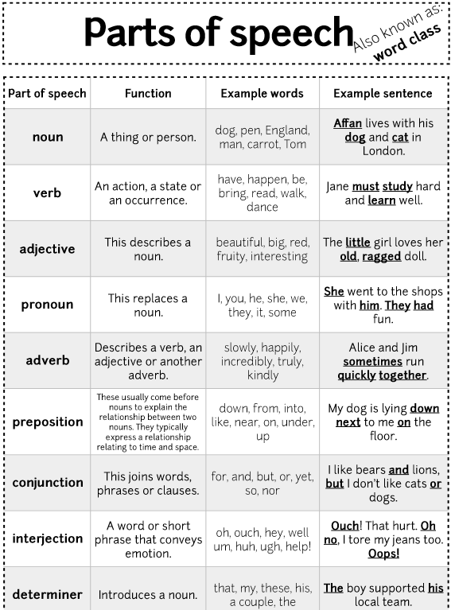

**Read the news article and record any vocabulary you are unsure of in the table below:**



<https://www.khaleejtimes.com/business/economy/Dubais-economic-growth-strengthens-ahead-of-Expo-2020>

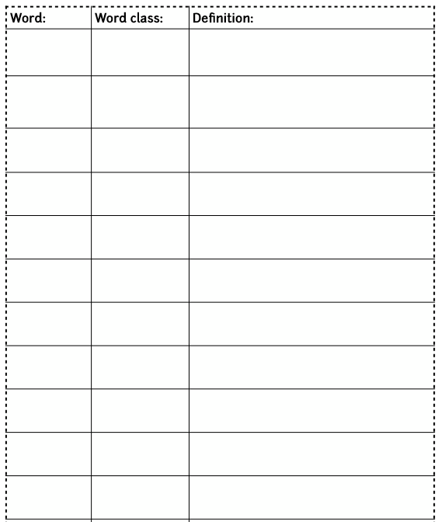

**Activity 7: Summarise the facts and information about Williiam Shakespeare below**



<https://www.bl.uk/people/william-shakespeare>

___________________________________________________________________________________________________________________________________________________________________________________________________________________________________________________________________________________________________________________________________________________________________________________________________________________________________________________________________________________________________________________________________________________________

____________________________________________________________________________________________________________________________________________________________________________________________________________________________________________________________________________________________________________

____________________________________________________________________________________________________________________________________________________________________________________________________________________________________________________________________________________________________________________________________________________________________________________________________________________________________________________________________________________________________________________________________________________________

____________________________________________________________________________________________________________________________________________________________________________________________________________________________________________________________________________________________________________

**Activity 8: Punctuation and verb agreement**

